How Students Send Their Accommodation Letters to Faculty Using the OAA Student Portal.
Students connected with the Office of Accessibility and Accommodation must send their letters to each instructor for the current or upcoming semester to activate their approved accommodations.
Use the following instructions to send letters to current faculty.

You will need the following information:
- Your NinerNET credentials
- Class schedule
- Test dates, start times, and in-class test duration

Steps for scheduling your test via the Student Portal:
The following steps can be used to schedule a test, midterm, or quiz in the Test Center. Use the Final Exam instructions for information on scheduling your Final Exams via the Student Portal.
- Go to https://accommodation.charlotte.edu/portal/
- Click the Student Portal icon

- Log in with your NinerNet credentials
  - If you have not recently logged in or are on a new device, you will need to use Duo two-factor authentication
- Once logged in, click on the “Request Accommodation Letters” icon on the left-hand side of the screen
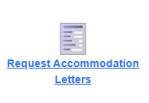
- A new page will display all courses you are registered for in the current semester. To view a different (or future) semester, use the drop-down menu on the right-hand side of the screen
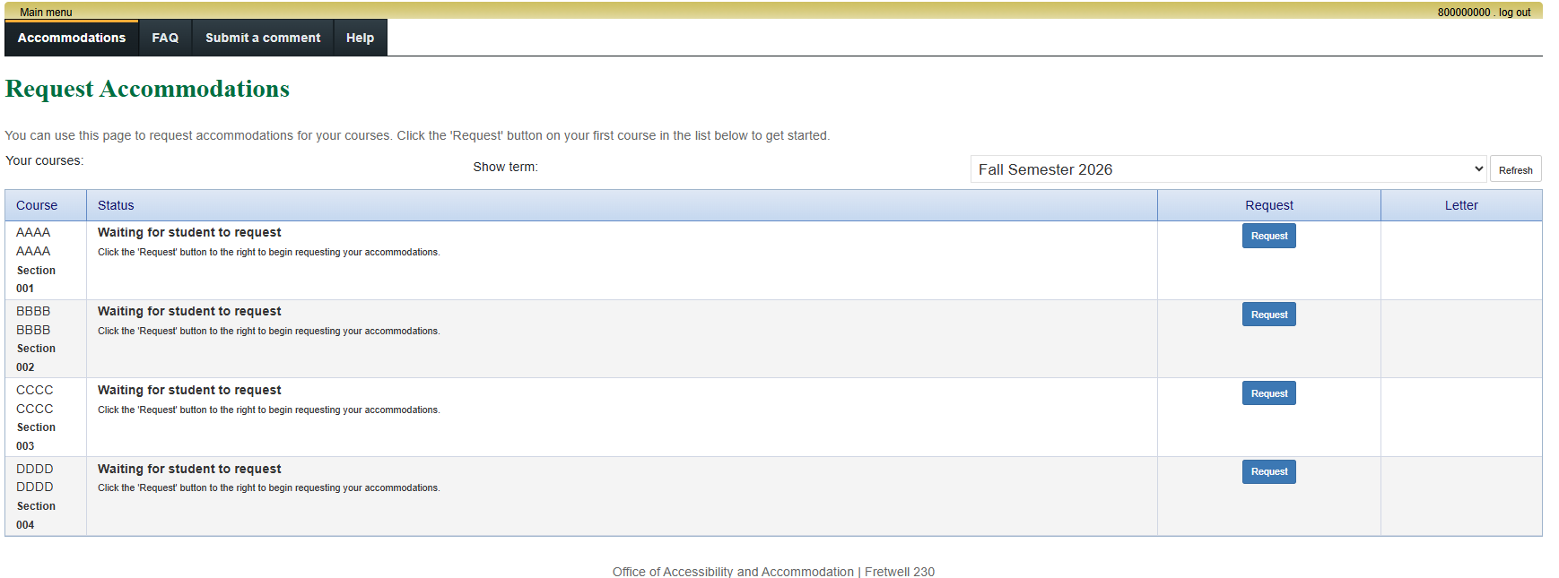
Click to select a different semester
- Once you are viewing the desired semester, click the blue “Request” button next to a course you want to send an accommodation letter for
  - You will know if you have not sent a current accommodation letter for a course if the blue Request” button appears in line with a course.
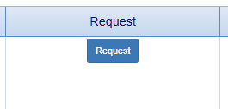
- You are now in the Request Accommodation module. The left-hand side of the screen will display all of your approved accommodation. The right-hand side of the screen will list each course you are currently enrolled in
- On the left-hand side, check the box for each approved accommodation you want to use in your course(s)
  - This page is customizable. Students should select each accommodation that they want to use in a specific course.
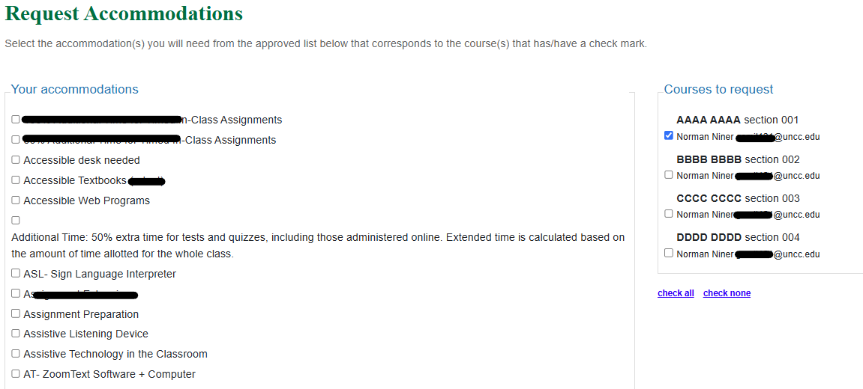

- On the right-hand side, check the box for each course you want to send an accommodation letter for with your selected accommodations
  - This page is customizable. Students should select each course they want to send a letter in with the selected accommodations. You can send multiple letters at once, or send them one at a time, depending on your needs
- Once you have selected your accommodations and courses, scroll to the bottom of the page where you will select that your accommodations are correct or select that you would like to talk about making a change
  - If you would like to make a change, we encourage you to email your OAA Team Member directly instead of leaving an Optional note. This will put you in touch with your Team Member quicker
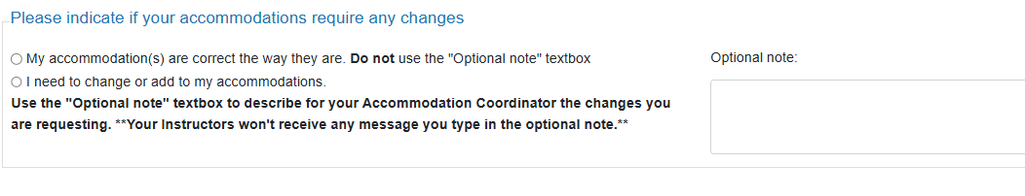
- Continue scrolling down the page, reading all information listed for helpful tips regarding using your approved accommodations
  - Links are embedded, when appropriate, with additional information from our office and the University
- At the bottom of the page, read through the agreement before selecting the checkbox acknowledging your read and understood all information above
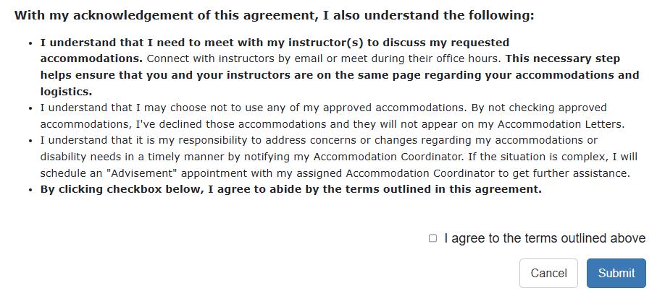
- Once you agree, click the blue “Submit” button at the bottom of the page. This will automatically send letters based on the boxes you checked above to instructors’ university email
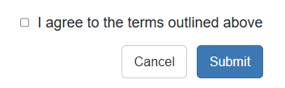
- Navigating back to the “Request Accommodations” page, you can now identify what courses you have sent an accommodation letter for
  - Each course where a professor has received an email about your accommodation letter will have a Status of “Sent”
  - Each course where a professor has viewed your accommodation letter will have a Status of “Confirmed”
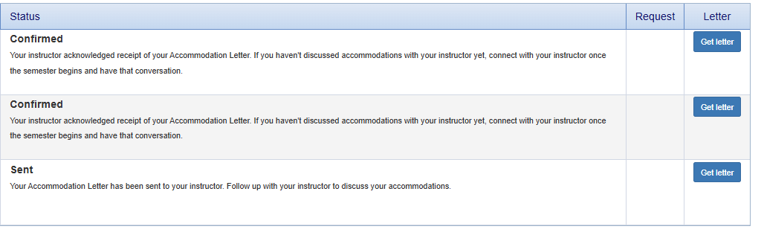
- To view the letter you sent and see what your professor sees, click the blue “Get letter” button in the Letter column next to the desired course
- To send an accommodation letter for another course, go back to step 6 and repeat the process until you have sent an accommodation letter for each course

*As a reminder, this process must be done every semester for every course you intend to use your accommodation for. Accommodations are not active until you have notified your instructors.

Questions? Email oaa-office@charlotte.edu 8/2026

